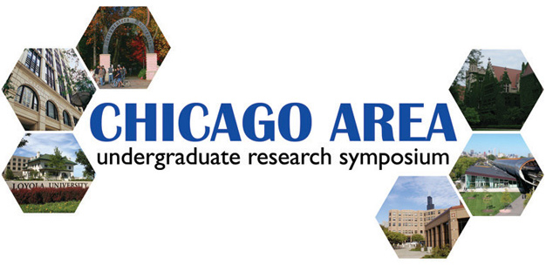

To CAURS volunteers:

Thank you again for participating in the 3rd annual Chicago Area Undergraduate Research Symposium! This year’s event promises to be an exciting and informative one with extremely impressive research projects, distinguished guests, and faculty judges.

Here is the information you need to know:

Schedule updates:

Our schedule can be found on page 3. We will be serving a light breakfast for early arrivals during registration, but we advise you to grab a bite to eat before your arrival. We would extremely appreciate if volunteers could arrive as early as 8:30 a.m. to help us set up, but no later than 9:30 a.m.

You are free to go anytime during the event, but please let one of the CAURS directors know. The current weather forecast as of April 7 reports a 40% chance of rain so please do not forget to bring an umbrella! You will be traveling outside between buildings for poster and oral presentations.

Transportation:

We strongly encourage you to use public transportation. The Chicago El Stop (Red Line) is only one block away from the Loyola Water Tower Campus. The map of the Water Tower Campus can be found on page 4. However, at your own risk (the following information was taken from the Loyola website), Loyola will be able to validate parking for the following garage if you arrive before 10 a.m.
Standard Parking
111 East Chestnut Garage
Chicago, IL. 60611
Phone: 312.640.1110 or 312.664.1198
1 hour or less | $15.00
2 hours or less | $20.00
3 hours or less | $22.00
3 hours to 10 hours | $25.00
10 hours to 24 hours | $31.00
Loyola Validations:
In by 10:00 a.m. & out by 7:00 p.m. | $11.00
In by 4:00 p.m. & out by 2:00 a.m. | $8.00
- Tickets must be validated at the desk in the lobby of 25 E. Pearson.
- All taxes are included in the price. All prices are subject to change.
Event details:

- Lunch will be served in the lower level of the Law Center on 25 E. Pearson. You are free to eat lunch there or visit local restaurants. Please do not abandon your post without notifying a CAURS director

- You are welcome to stay for the banquet. If you are not staying for the banquet, you are still encouraged to listen to the research lecture by Dr. Thomas Meade of Northwestern University, which will be held directly before and in the same hall as the banquet.

- Awards will be given to the top poster presentation in each subject, the overall top poster presentation (Cribari President’s Award), top oral presentation, and top research proposal (pre-determined by the CAURS committee).

- This event requires business professional attire for student participants. However, volunteers will be given a special CAURS polo shirt upon arrival to wear during the event (which you are free to keep afterwards). Please plan on wearing pants that will match a white polo shirt. Because you may often be the first CAURS staff that participants will meet upon arrival, it is important to look your best.

Please email info@caurs.com or visit our website at www.caurs.com if you have any questions or concerns. Thank you and see you on April 14, 2007!

